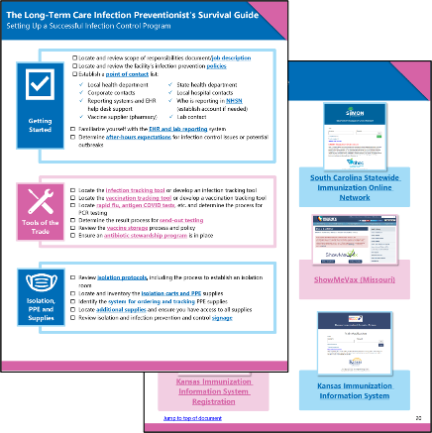
Resources Tackle Infection Prevention and Immunization
Infection prevention and vaccinations go hand in hand – together, they boost protection to keep us all healthier.

In its continued efforts to reduce the risk of infection in healthcare settings, Health Quality Innovators (HQI) developed the following resources.

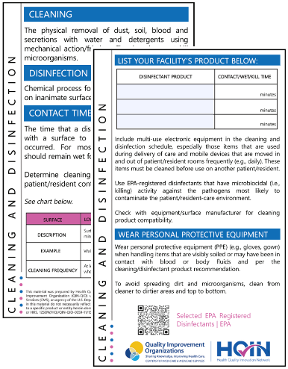
- The Long-Term Care Infection Preventionist’s Survival Guide is ideal for new infection preventionists and features guiding checklists and resources to create or enhance an infection prevention and control program.
- The Best Practices Pocket Cards can be downloaded, printed, laminated and distributed to staff. Featured topics include injection safety; survival of microorganisms on inanimate objects and surfaces; cleaning and disinfection; and skin care for infection prevention.
- The Your Health Can’t Wait, Vaccinate campaign resources include sample social media messaging, vaccine encouragement email signatures, flyers and customizable display materials.
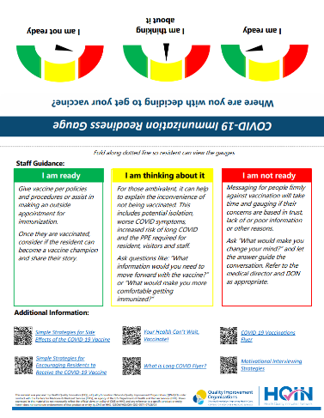
- The Vaccine Hesitancy/Misinformation Resources collection features motivational interviewing strategies and a readiness gauge tool to guide a conversation with those who are ready to be vaccinated, considering getting vaccinated or firmly against vaccination.
- The Survey Readiness Toolkit is comprised of tools designed to assist in everyday compliance and help prepare for surveys and inspections. It can also be used to train new employees during onboarding and annually.

Visit the Health Quality Innovation Network’s Resource Center to access additional tools to help promote immunization and infection prevention.

